IY4101 – Practical Programming

Object-Oriented Programming: Shape Management System
Abdul Raheem Kashif
Student ID: 303065799
Module: IY4101 Practical Programming
Assignment: Practical Programming Assignment 2
Submission Date: 1 April 2026
I confirm that this assignment is my own work.

Program Design
This program is designed using object-oriented programming principles to represent and manage a collection of geometric shapes. The aim of the system is to create a console-based Java application that allows different shapes to be stored, manipulated, and displayed while demonstrating the use of classes, inheritance, and method overriding.
The design centres around a superclass called Shape, which defines the common properties and behaviours shared by all shapes in the system. Each shape has a position on a two-dimensional coordinate plane and provides functionality for calculating its area, calculating its perimeter, translating its position, scaling its dimensions, and displaying its information. Rather than implementing this behaviour separately for every shape type, the shared structure is defined once in the Shape class and then reused by subclasses.
Four subclasses extend the Shape class: Rectangle, Square, Circle, and Triangle. Each subclass represents a specific geometric shape and provides its own implementation of the methods used to calculate area, perimeter, scaling behaviour, and display information. While the structure of each shape is inherited from the parent class, the mathematical calculations differ depending on the geometry of the shape. This approach reduces code duplication and allows the program to treat different shapes in a consistent way.
A separate Coordinates class is used to represent positions in two-dimensional space. Instead of storing x and y values directly in multiple classes, the program uses a dedicated class to manage coordinate data and related operations. This improves encapsulation because the coordinate logic is stored in one place, making the design easier to maintain and extend.
The program also includes a ShapeList class, which manages a collection of shapes. This class stores shapes inside an ArrayList<Shape> and provides operations such as adding shapes, removing shapes, retrieving shapes by position, translating shapes, scaling shapes, and displaying information about the stored shapes. Separating the list management from the shape classes helps keep responsibilities clearly organised.
Finally, the ShapeManagement class acts as the main controller of the application. This class contains the menu-driven interface that allows the user to interact with the system. Through the menu, the user can create shapes, remove shapes, display information about shapes, translate shapes, scale shapes, and exit the program. The class connects the user interface to the functionality provided by the ShapeList class.
Overall, the design separates the responsibilities of shape representation, coordinate management, list management, and user interaction. This modular structure makes the system easier to understand, test, and maintain. It also reflects key object-oriented programming concepts including encapsulation, inheritance, and polymorphism.

Class Structure
Coordinates Class
The Coordinates class represents a point in two-dimensional space using two integer values, x and y. It provides methods to retrieve the coordinate values, calculate the distance between two points, translate the point by a given amount, scale the coordinate values, and display the position as text.
This class is used by other classes to represent positions and vertices. By keeping coordinate-related functionality in one class, the program avoids repeating similar code in multiple places.

Shape Class
The Shape class acts as the superclass for all shapes in the system. It stores the position of the shape using a Coordinates object and defines common behaviour shared by all shapes.
The class includes methods for retrieving and setting coordinates, translating the shape, scaling the shape, calculating area, calculating perimeter, and displaying shape information. While the class defines these methods, the specific calculations for area and perimeter are implemented by the subclasses.

Rectangle Class
The Rectangle class extends the Shape class and represents a rectangle with a width and length. The constructor sets the position and dimensions of the rectangle.
The class overrides the methods for calculating area and perimeter, where the area is calculated using width × length and the perimeter is calculated using 2 × width + 2 × length. The scaling method adjusts the rectangle dimensions, and the display method outputs the rectangle information.

Square Class
The Square class also extends the Shape class. It represents a square with a single side length.
The area is calculated using side × side, and the perimeter is calculated using 4 × side. The scaling operation changes the side length, and the display method outputs the square’s details.

Circle Class
The Circle class represents a circle defined by a radius. The class extends the Shape class and overrides the required methods.
The area is calculated using the formula πr², and the perimeter (circumference) is calculated using 2πr. Scaling changes the radius value, and the display method outputs the circle’s information.
Triangle Class
The Triangle class extends the Shape class but differs slightly from the other shapes because it is defined using three vertices instead of a single dimension.
The triangle stores three coordinate objects representing its vertices. The perimeter is calculated by measuring the distances between the three points, and the area is calculated using Heron’s formula. Translation moves all three vertices by a specified distance, and scaling adjusts the triangle proportionally.

ShapeList Class
The ShapeList class manages a collection of shapes stored inside an ArrayList. It provides methods to add shapes, remove shapes, retrieve shapes by position, translate shapes, scale shapes, and display information about all stored shapes.
This class acts as the central data structure for the system and allows multiple shapes to be managed within a single program.

ShapeManagement Class
The ShapeManagement class is the entry point of the application. It provides the menu system that allows the user to interact with the program.
The menu allows the user to perform actions such as:
- adding shapes
- removing shapes
- retrieving information about a shape
- displaying all shapes
- translating shapes
- scaling shapes
- exiting the program
This class controls the program flow and connects the user interface with the functionality implemented in the other classes.
Implementation Discussion

The implementation of the system follows object-oriented programming principles to ensure the program is organised, reusable, and easy to maintain. A superclass called Shape was used to define common properties such as position and shared methods like translation and scaling. This avoids repeating the same code in each shape class and makes the system more efficient.

Inheritance was used so that Rectangle, Square, Circle, and Triangle could extend the Shape class. This allowed each shape to reuse common behaviour while also providing its own implementation of methods such as area and perimeter. This approach makes the program more flexible because new shapes can be added in the future without changing the existing structure.

Polymorphism is also used in the program through the ShapeList class. Shapes are stored using an ArrayList of type Shape, which means different types of shapes can be handled in the same way. For example, when displaying shapes or calculating area and perimeter, the program calls the same method but each shape produces its own result. This makes the system easier to extend and reduces the need for multiple conditional statements.

An ArrayList was used to store shapes because it allows dynamic resizing, meaning the user can add or remove shapes without needing to define a fixed size. This makes the system more flexible compared to using arrays.

The menu-driven system was implemented using loops and conditional statements. This allows the program to continuously run and respond to user input until the user chooses to exit. This improves usability as the user can perform multiple operations in one session.

Overall, the implementation focuses on reducing code duplication, improving flexibility, and making the program easier to extend in the future.

UML Class Diagram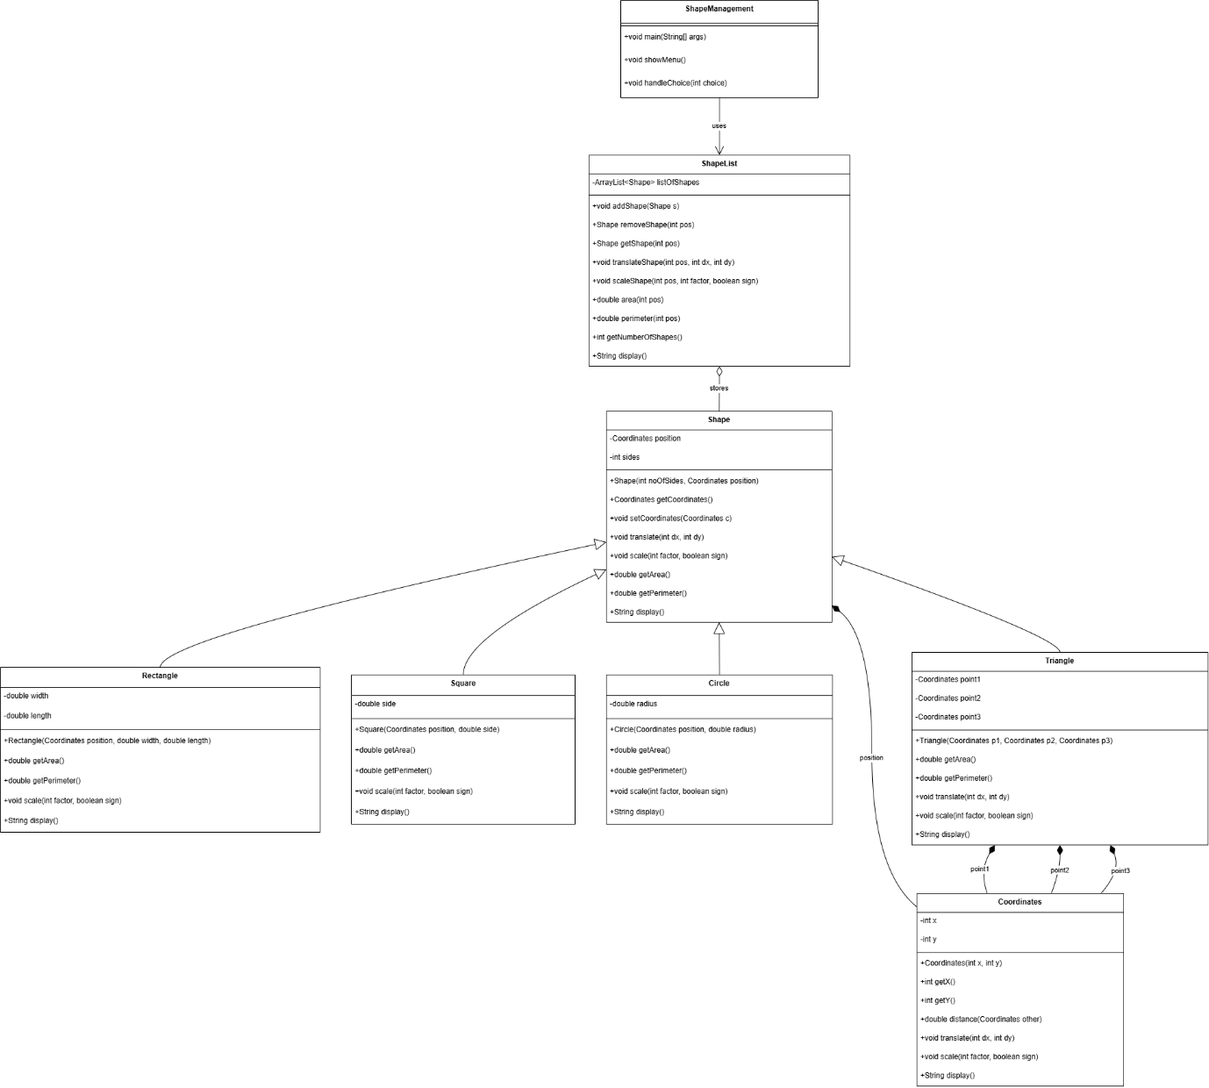
Figure 1: UML Class Diagram for the Shape Management System
This diagram illustrates the class structure of the program, showing the relationships between the main classes used in the system. The Shape class acts as the superclass, while Rectangle, Square, Circle, and Triangle inherit from it. The Coordinates class represents positional data for shapes, while ShapeList manages the collection of shapes stored in the program. The ShapeManagement class provides the menu-driven interface and controls the overall execution of the application.

Testing Section
The program was tested using a variety of inputs to ensure all features worked correctly. Different shapes were added to the system and their area and perimeter values were checked to confirm accuracy. Translation and scaling operations were tested to ensure that shape positions and dimensions updated correctly.

Additional testing was carried out by performing multiple operations in sequence, such as adding shapes, displaying them, and then modifying them. This helped confirm that the program maintains correct data throughout execution.

Overall, the system performed as expected with no runtime errors, and all features produced correct results.

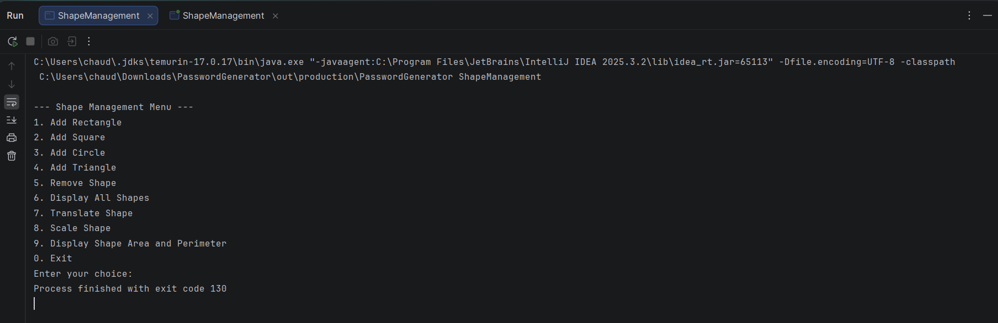
Figure 2: Program menu displayed when the Shape Management system is executed

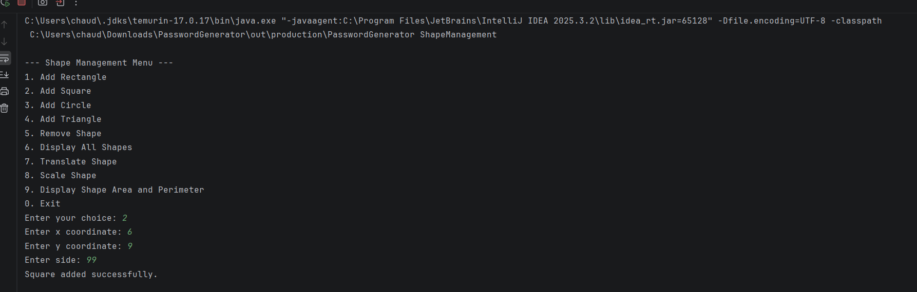
Figure 3: Adding a square to the system using user input

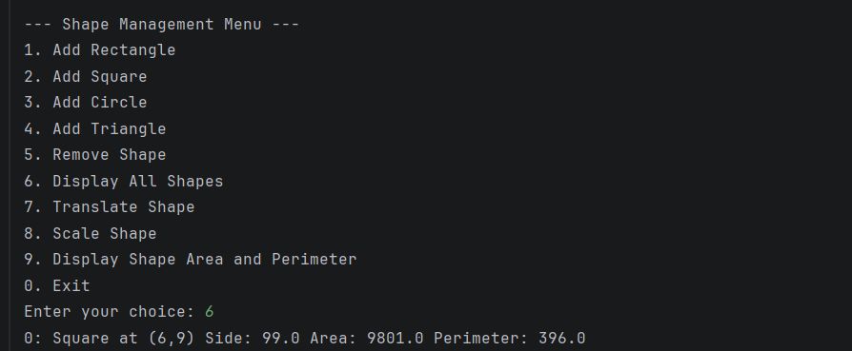
Figure 4: Displaying all shapes along with their area and perimeter

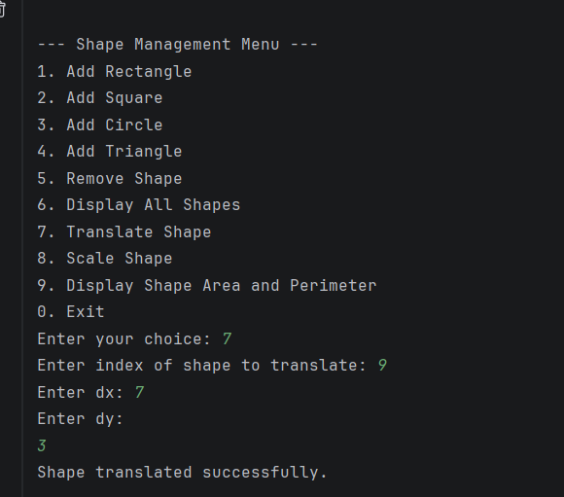
Figure 5: Translating a shape by modifying its coordinates

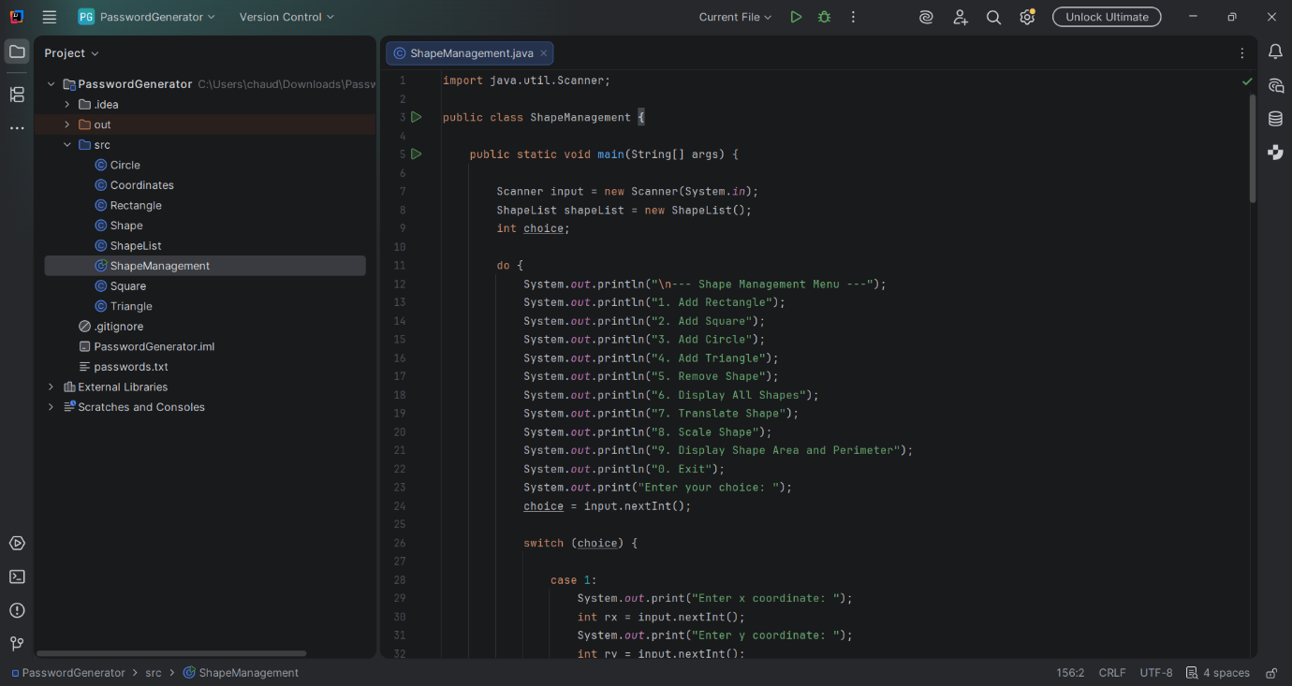
Figure 6: Full execution of the program showing menu interaction and operations

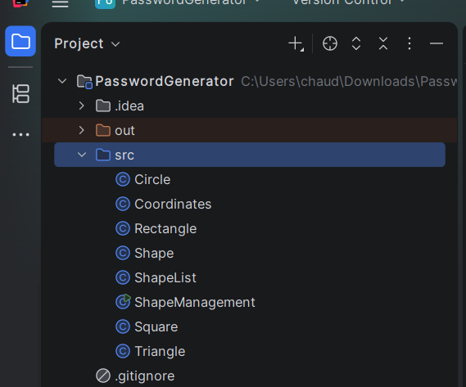
Figure 7: Project structure showing all implemented classes in the system
Reflection
This assignment helped me develop a stronger understanding of object-oriented programming and how different concepts work together in a complete system. By using a base Shape class and extending it into different subclasses, I was able to apply inheritance to reduce repetition and improve code organisation.

I also gained a better understanding of how polymorphism allows different objects to be treated in the same way while still producing different results. This was particularly useful when storing shapes in the ShapeList class, as it allowed the program to handle multiple types of shapes using a single structure.

One of the challenges I faced was implementing the triangle, especially calculating its area and perimeter using coordinates. This required more complex calculations compared to other shapes. However, by breaking the problem into smaller steps and testing each part, I was able to complete it successfully.

If I were to improve this system further, I would add input validation to handle incorrect user input and prevent errors. I would also consider improving the user interface to make the program easier to use.

Overall, this assignment improved my confidence in designing and implementing object-oriented programs and helped me understand how to structure code in a more organised and flexible way.

